**USER FEEDBACK AND USABILITY**

**230701221**

**M.Nithyashree**

This exercise is about designing an application with different layouts and colour schemes. It is then used to get the feedback from the user and then made changes to test the usability. The application in use is **“THE SHOPPING APP”.**

**This exercise contains of phases:**

**Phase 1: Introduction**

User Feedback and Usability are two important parts of making a successful product.

User feedback tells us what users feel about the product. Usability means how easy and comfortable the product is for users. Both help to make better designs.

**Phase 2: Planning for Feedback and Usability**

Before collecting feedback, we should plan carefully.

We must decide what we want to find out, who the users are, and how we will collect their feedback. Good planning saves time and gives better results.

**Phase 3: Collecting User Feedback**

Now, we collect feedback from real users.

We can use surveys, interviews, usability testing, or simply observe users while they use the product.

This phase gives us direct information about user problems and suggestions.

Surveys (questions to many users)

Interviews (talking one-on-one)

Usability testing (watching users use the product)

Observations (noticing where users struggle)

**Phase 4: Analyzing Feedback**

After collecting feedback, we must carefully study it.

We should find patterns — what problems are common, what users like, and what needs to be changed.

Grouping feedback helps to find major and minor issues.

Find common user problems

Highlight what users like

Group similar feedback together.

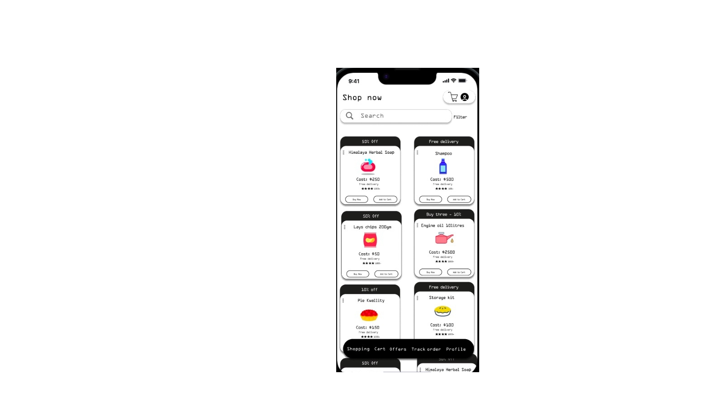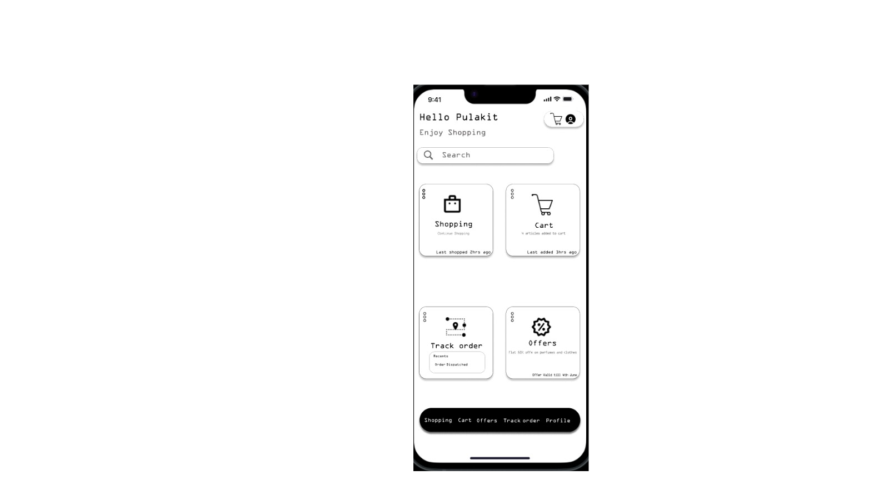 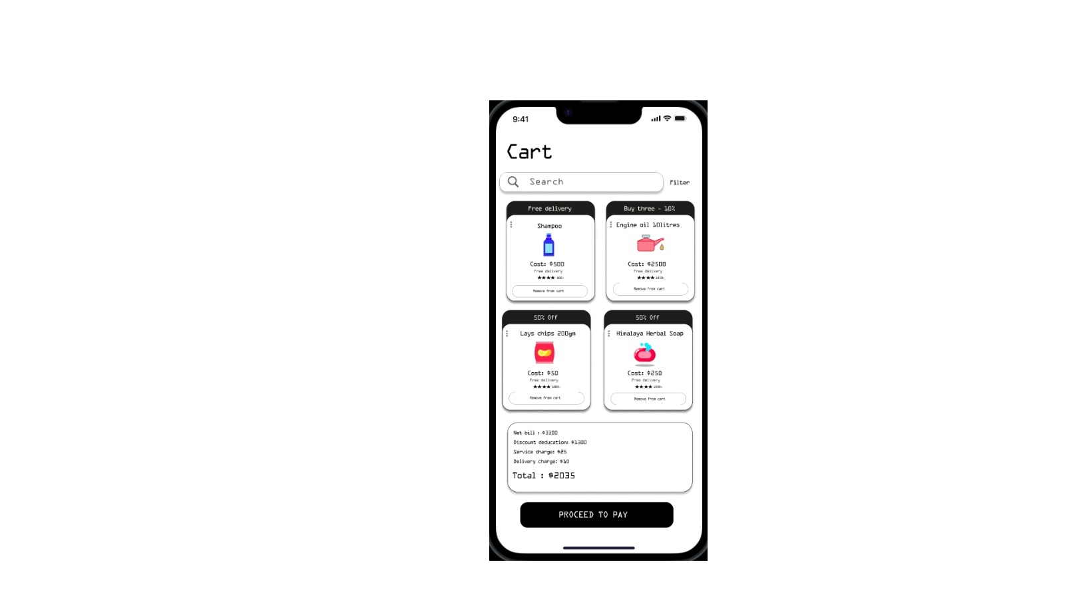

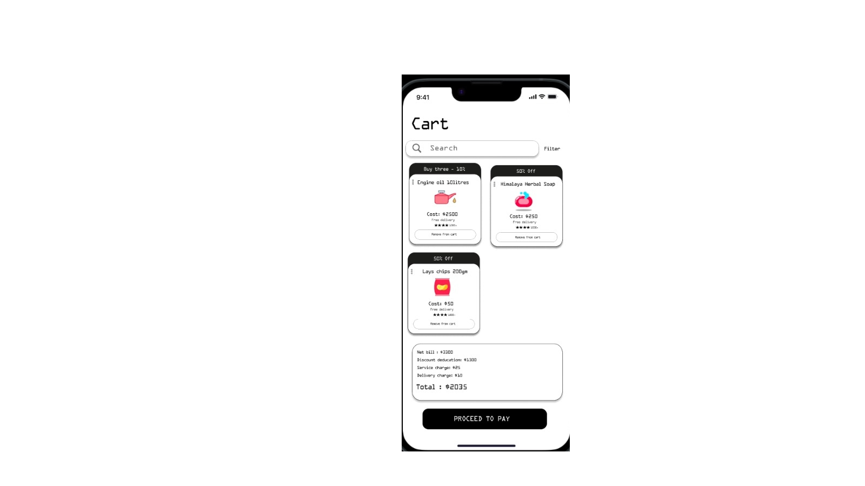 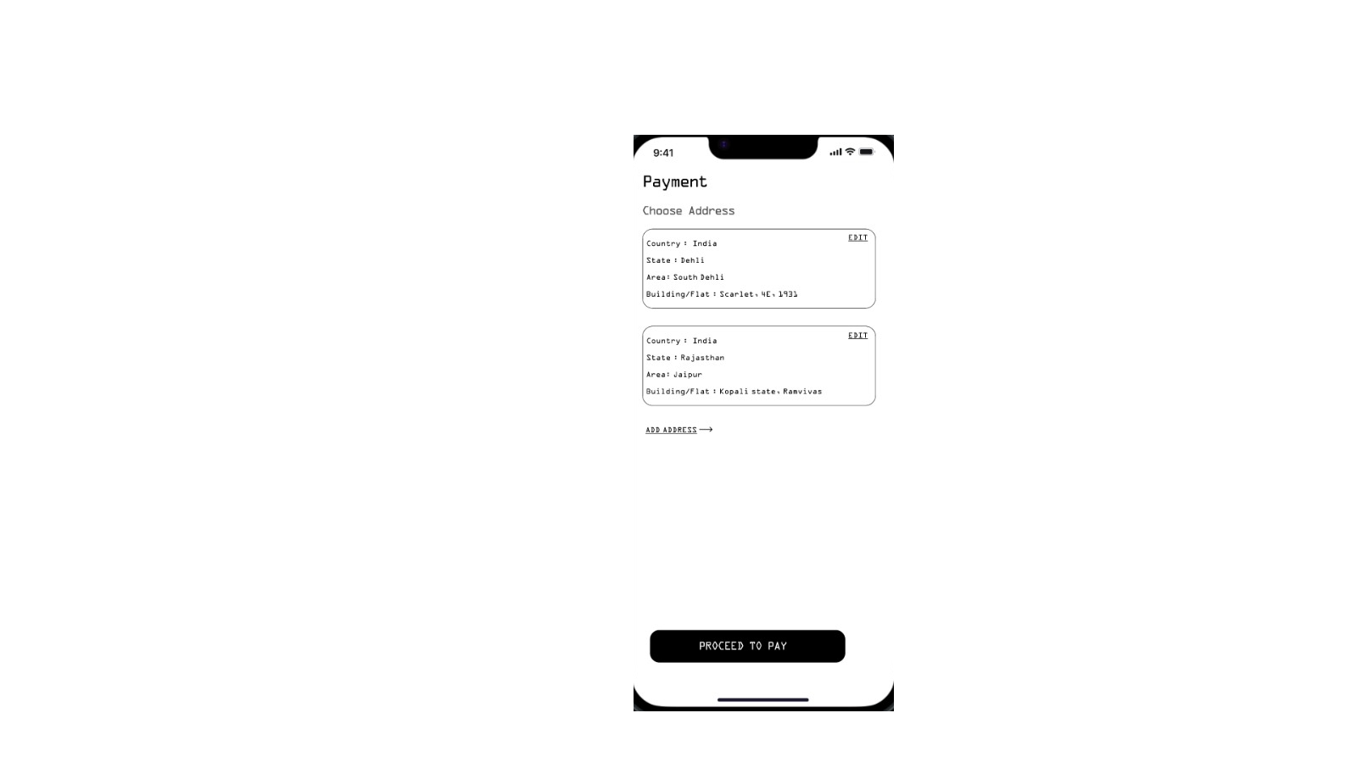 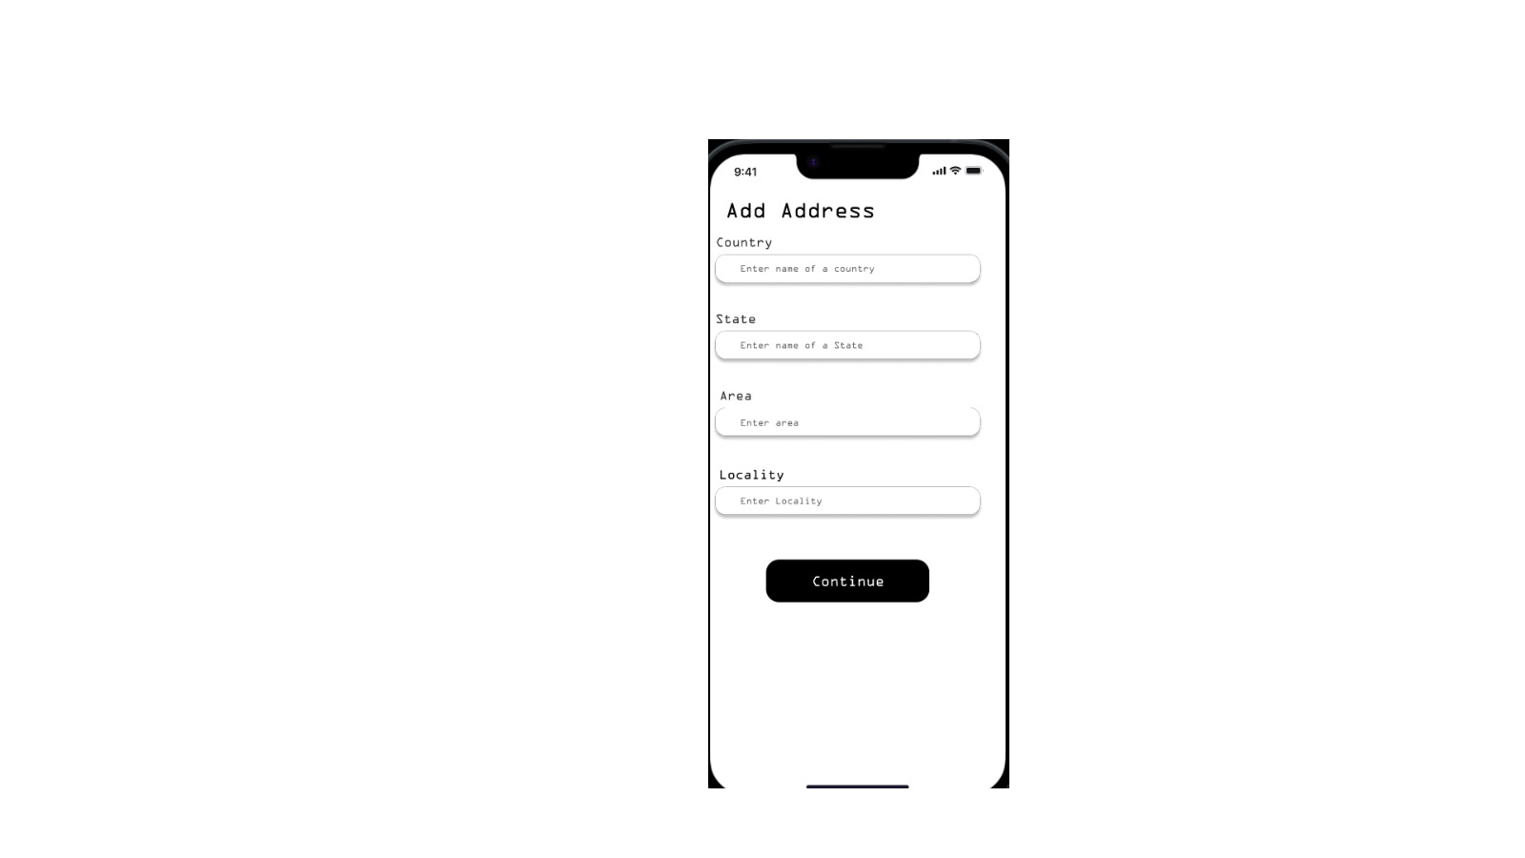

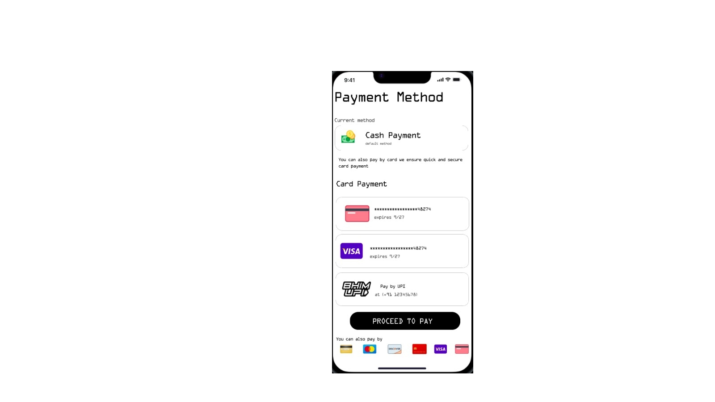 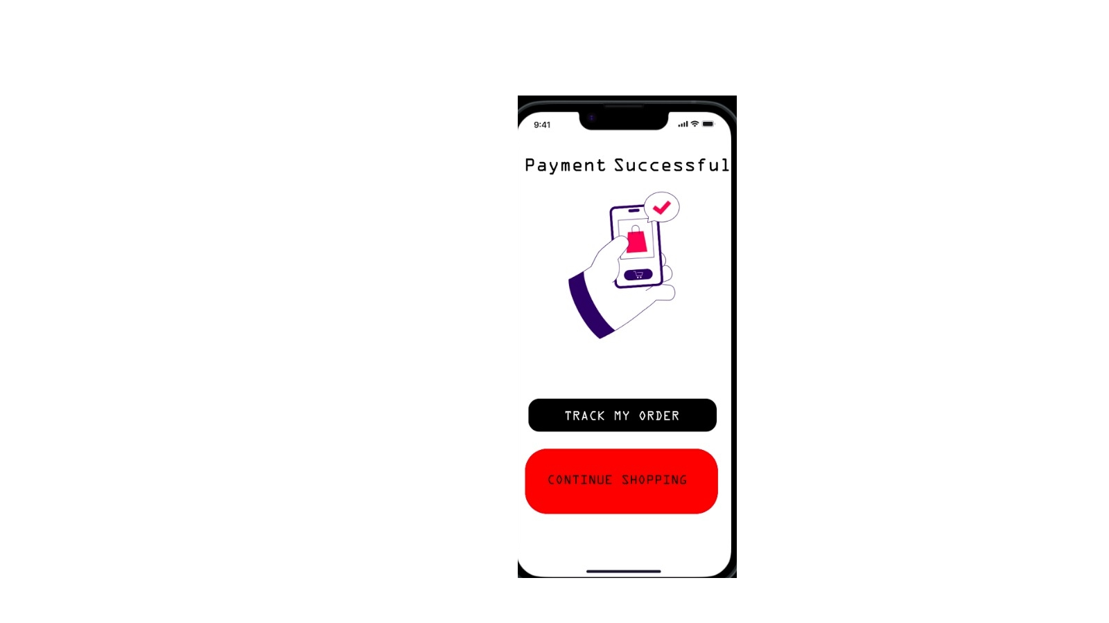

**Phase 5: Making Improvements**

In this phase, we start improving the product.

We fix the problems users faced, make designs more simple, and add what users requested.

After making changes, we should again check if the issues are solved.

Solve usability problems

Make interface more user-friendly

Improve based on feedback.

**Phase 6: Final Usability Evaluation**

After improvements, we do a final usability check.

We ask users to try the product again and see if they find it easier and better.

If users are satisfied, the design is ready. If not, we repeat small changes.

Test if usability is improved

Confirm user satisfaction

Make final small changes if needed.

**Phase 7: Conclusion**

User Feedback and Usability work together to create successful products.

Without user feedback, we cannot know real problems. Without good usability, users may leave the product.

Always listen to users, improve the design, and test regularly.

Feedback ➔ Shows problems

Usability ➔ Solves problems